Unattended SQL Installation – 2012 SQL Cluster Install
- Make sure you copied the SQL binaries to D:\ drive with “SQL2012SetupFiles” folder name. If the drive or folder name changes, please change the folder path on the batch file. Currently the folder within the batch file is D:\SQL2012SetupFiles.
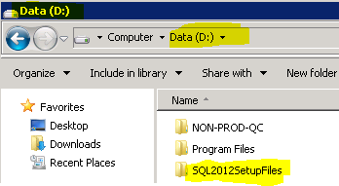 | 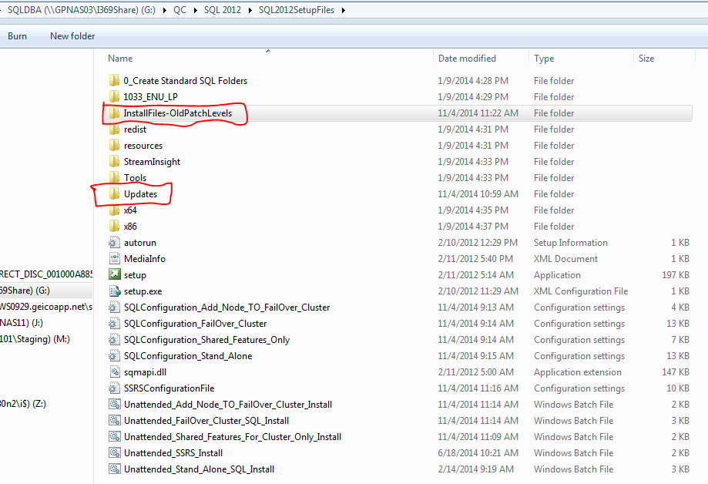
Fig. 1 SQL Binary location and its contents
- Open the first folder “0_Create Standard SQL Folders” and run the batch file as administrator. The root directory will be where the database, transaction log, tempdb and backups will be resided. Use the format as shown below with drive letter, colon ( : ) and backward slash (\). The drive name could be SQL, SQL1, SQL2 or SQL3 ….. According to your server.
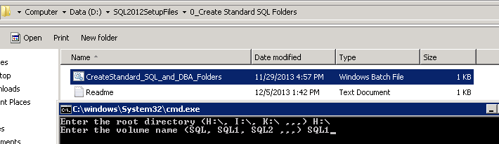
Fig. 2 Standard SQL Folders ( On Mount Volume Drives)
Note: Please verify all SQL folders are created. For instance :\DBA\OUTPUT and SSIS :\SQL1_Backup\DBBKUP
- Make sure the required patch level files (Service Pack and Cumulative Update) are copied over to the “Updates” folder as shown below. In general, the latest patch level files will be kept in the “Updates” folder. As of now, Nov 04, 2014, “Updates” folder contains SQL Server 2012 Service Pack 2 and Cumulative Update 2.
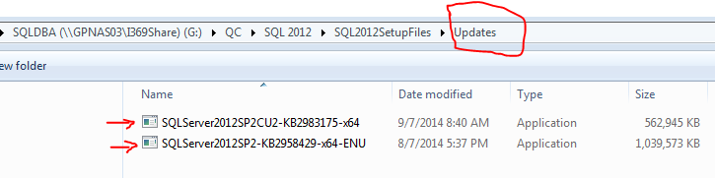
If you need to install older patch level, for instance SQL Server 2012 SP1 CU4, copy the patch files (SP1 + CU4) from “InstallFiles-OldPatchLevels” and copy them to the “Updates” folder.
NOTE: Keep ONLY patch files that you want to install in “Updates” folder. Two files - One Service Pack and/ or one Cumulative Update file.

- Edit the batch files depending on your requirements (Stand-Alone or Cluster)
- Edit the batch file “Unattended_FailOver_Cluster_SQL_Install” with the current server information. To make your life easy, wrap the text on the notepad. (Go to Format →Word Wrap). Edit the parameters on the batch file according to your cluster information
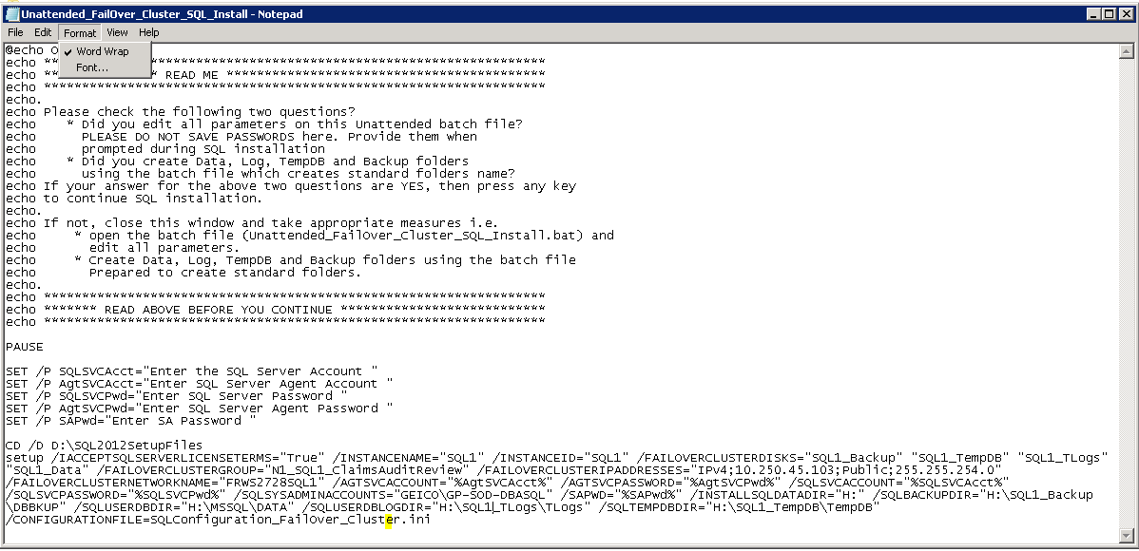
Fig.3 Edit the parameters in the BATCH files
/IACCEPTSQLSERVERLICENSETERMS="True"
/INSTANCENAME="SQL1"
/INSTANCEID="SQL1"
/FAILOVERCLUSTERDISKS="SQL1_Backup" "SQL1_TempDB" "SQL1_TLogs" "SQL1_Data" "SQL1_Data1" (Fig. 4 – Disk Drives attached to the Clustered Group)
/FAILOVERCLUSTERGROUP="N1_SQL1_xxxxxxxx" (Please use the cluster group name) /FAILOVERCLUSTERIPADDRESSES="IPv4;xx.xxx.xxx.xxx;Public;255.255.254.0" (IPv4 is an IP reserved for the cluster by NOC/MIT and the next part is name of the subnet. Currently WIS team uses different subnet names like Public/Public Team/Cluster Network/or something different). Please refer Fig.5 Public Network Name for how to decide which name to use. Use IPconfig to determine the subnet IP, usually in geico and geicoapp it is 255.255.254.0 )
/FAILOVERCLUSTERNETWORKNAME="FRWS1801SQL1" (Cluster Network Name)
****************** The following parameters will be prompted during execution of the batch file and will be supplied with the values i.e. SQL server engine service account and passwords also SQL Server Agent account and passwords ****************************
/AGTSVCACCOUNT="%AgtSVCAcct%" (SQL Agent Service Account parameter)
/AGTSVCPASSWORD="%AgtSVCPwd%" (SQL Agent Service Account password parameter)
/SQLSVCACCOUNT="%SQLSVCAcct%" (SQL Server Engine Service Account parameter)
/SQLSVCPASSWORD="%SQLSVCPwd%" (SQL Server Engine Service Account Password parameter)
/SQLSYSADMINACCOUNTS="GEICO\GP-SOD-DBASQL"
/SAPWD="%SAPwd%" (SQL Server “sa” password parameter)
/INSTALLSQLDATADIR="H:"
/SQLBACKUPDIR="H:\SQL1_Backup\DBBKUP"
/SQLUSERDBDIR="H:\MSSQL\DATA"
/SQLUSERDBLOGDIR="H:\SQL1_TLogs\TLogs"
/SQLTEMPDBDIR="H:\SQL1_TempDB\TempDB" /CONFIGURATIONFILE=SQLConfiguration_FailOver_Cluster.ini

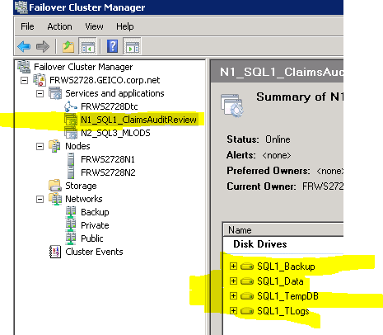
Fig. 4 – Disk Drives attached to the Clustered Group
Check the network Name on the Failover Cluster Manager
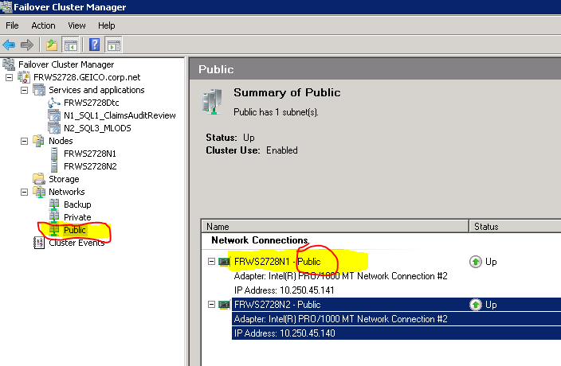
Fig. 5 Public Networks name (It could be Public or Public Network or Cluster Network)
If this is NOT the first 2012 SQL installation on the server, either stand alone or cluster, edit the following SQL configuration .ini file (SQLconfiguration_Fialover_Cluster).
- Use the FEATURES indicated by arrow number 1 if this is first time 2012 SQL installation is taking over (This is a default setup).
- Use the FEATURES indicated by arrow number 2 if it’s NOT first time 2012 SQL installation. Please check the prior SQL installation with 2012 SQL Server Configuration Manager. Remove the semi-colon ( ; ) in front of arrow # 2, and add semi-colon ( ; ) in front of arrow # 1 and save the configuration file.
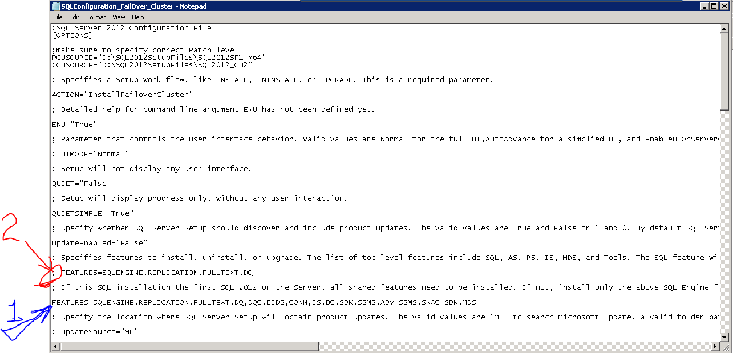
Fig. 6 Edit the configuration (.ini) file(SQLconfiguration_Fialover_Cluster) in the SQL binary folder
- Execute the batch files and provide Server Name, Max Server Memory and all necessary credentials for the SQL server Engine and Agent accounts and also “sa” password.

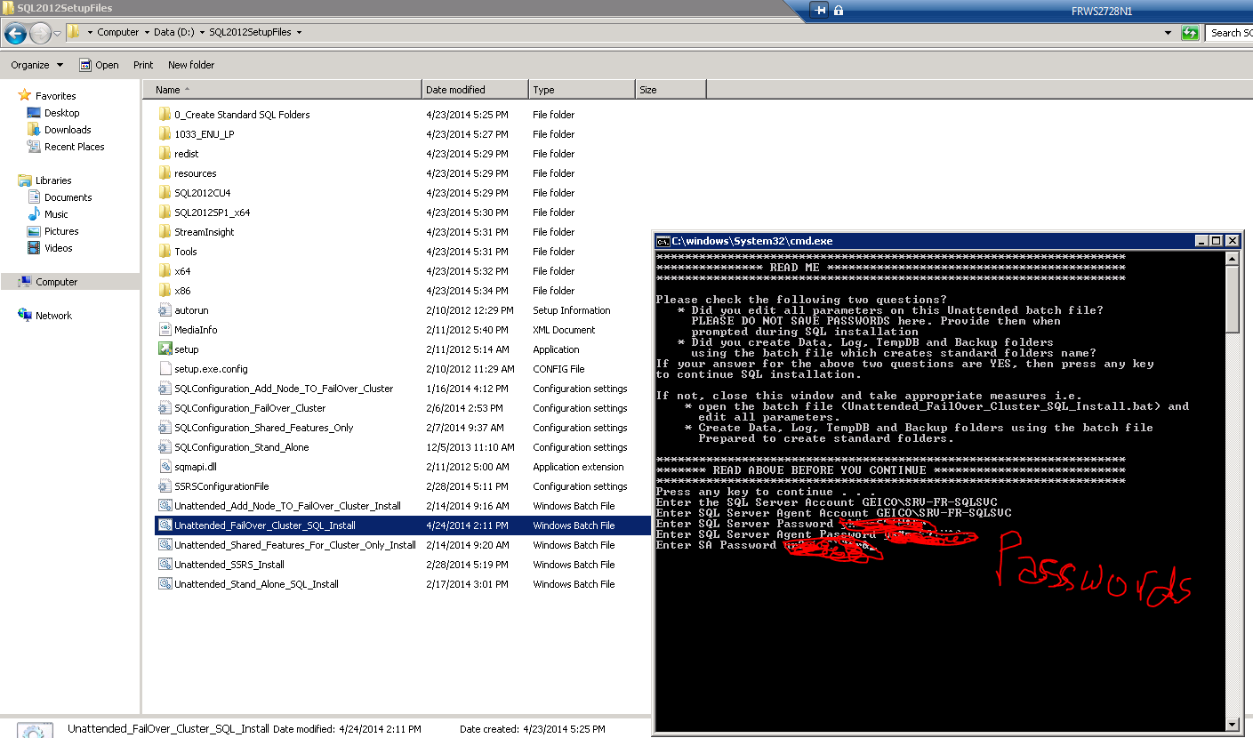
Fig. 7 Run the batch file as Administrator
- If the installation fails, please refer the “Log” file under the following path and last folder (based on the time you installed – Folder Name would be “yyyymmdd-hhmmss”). Open the folder and locate the text file “Summary_ServerName_yyyymmdd_hhmmss” same date and time stamp as on the folder.
C:\Program Files\Microsoft SQL Server\110\Setup Bootstrap\Log → latest folder

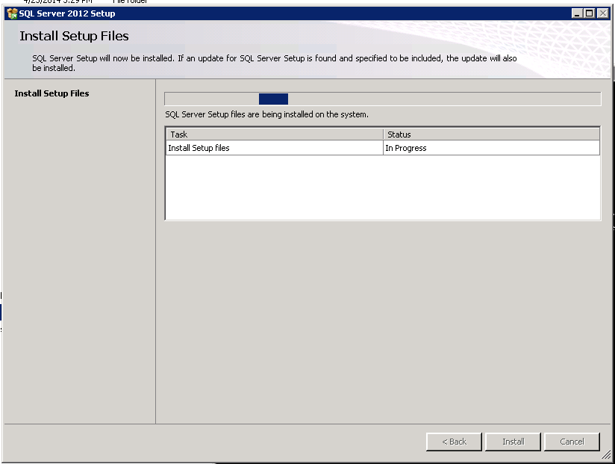
Fig. 8 SQL Server 2012 Setup
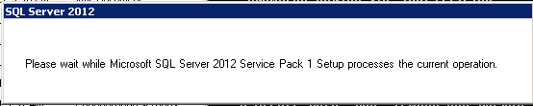
Fig. 9 Check with Service Pack 1
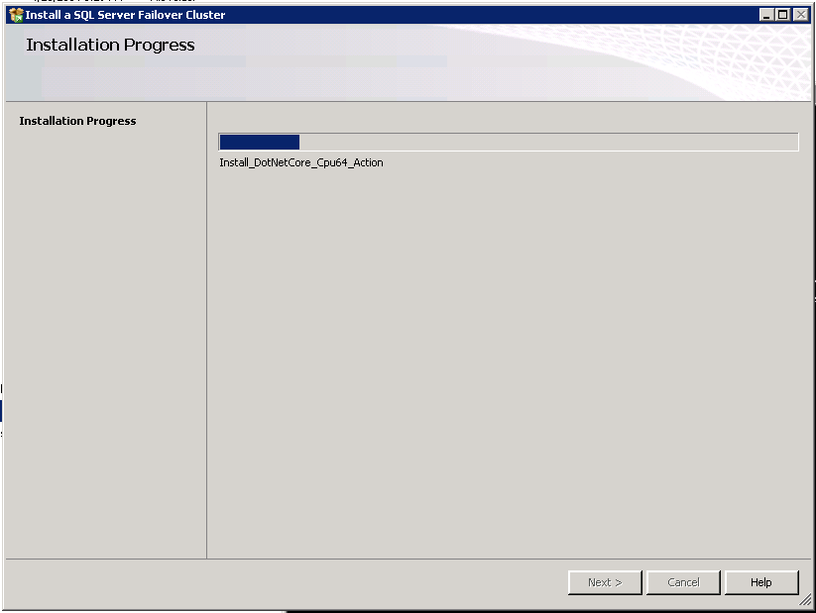
Fig. 10 Installing a SQL Server Failover Cluster
The last step is to run QC script according to the environment. There are two types of QC: Prod and Non-Prod QC script. There is a batch file inside the QC folder to run as Administrator.

Shared Features Only Installation (On the Secondary Node)
(Please perform this activity if and only if this is the first SQL 2012 installation on this node)
At GEICO we install SQL Server on D:\ drive. In order to maintain this policy, we’ll install shared features only to the secondary node before adding failover cluster node to the secondary node. Otherwise, when the failover cluster node is added to the secondary, the shared features will be installed on c:\ drive as it is Microsoft’s default drive.
NOTE: If SQL Server 2012 has been installed on the server for other applications, then installing shared features is unnecessary as the shared features are common for all SQL installations. However, please verify the first SQL installation has been installed on D:\ drive.
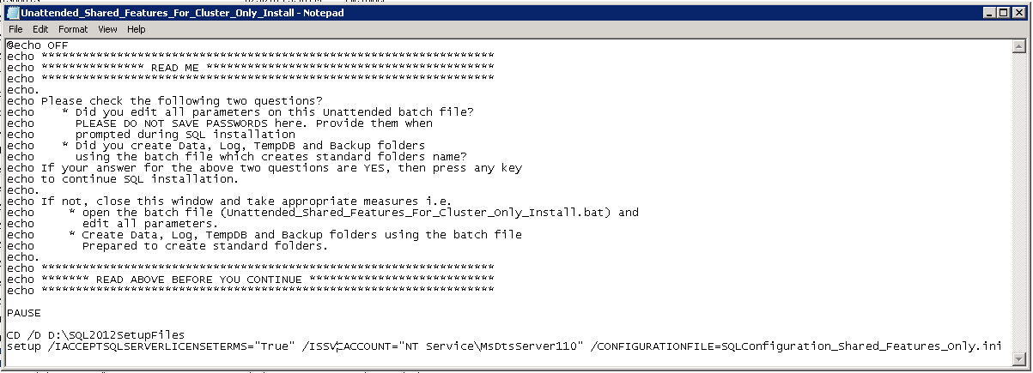
Fig. 11 Unattended_Shared_Features_For_Cluster_Only_Install BATCH file
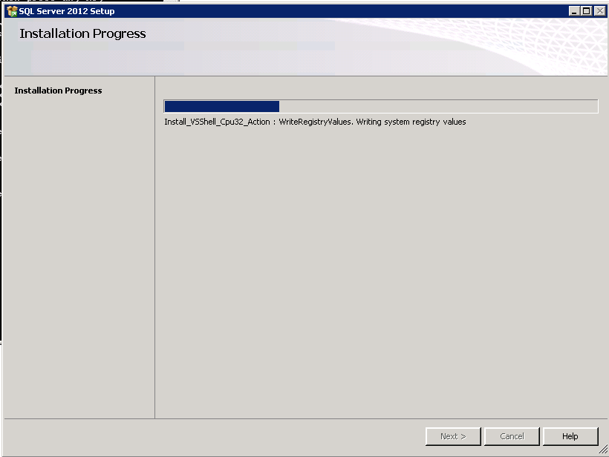
Fig. 12 Shared Features Installation in progress

Add Secondary Node to SQL Failover Cluster
SQL Server 2012 installation on the primary node and Shared features installation on the secondary node should be completed before adding node to the failover cluster. This installation will be done on the secondary node.
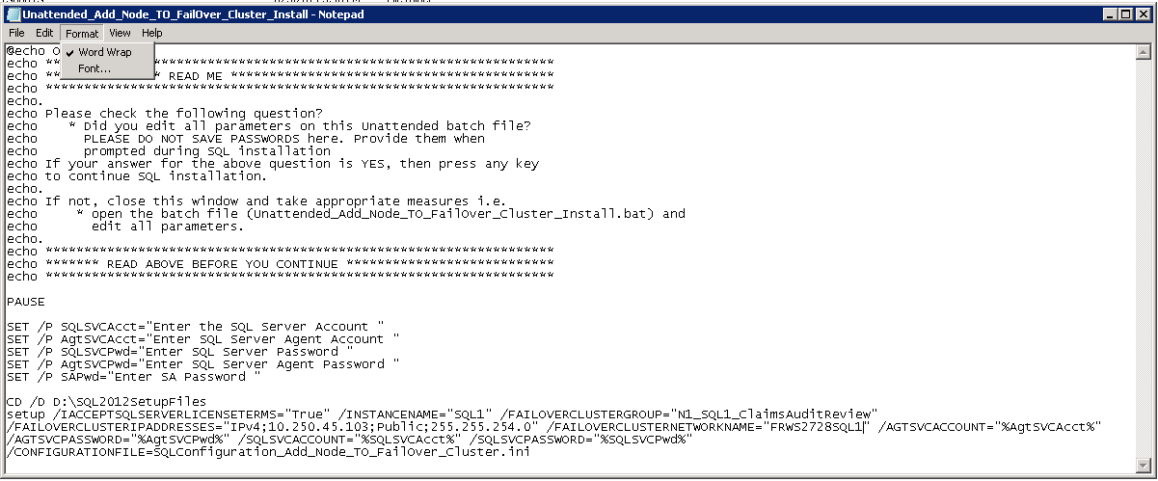
Fig. 13
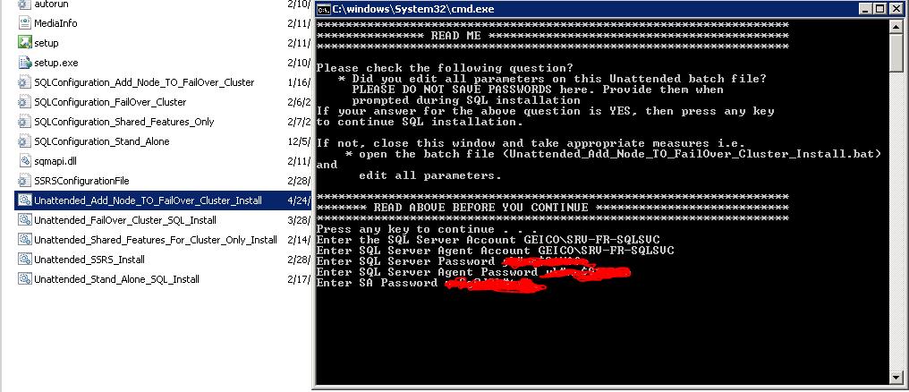
Fig. 14

